Questions and Exercises to work out and turn in:

Grading Guidelines:

* A right answer will get full credit when:

1. It is right (worth 25%)
2. It is right **AND** neatly presented making it easy and pleasant to read. (worth an **extra** 15%)
3. There is an **obvious and clear link** between 1) the information provided in the exercise and in class and 2) the final answer. A clear link is built by properly writing, justifying, and documenting an answer (worth an **extra** 60%).
4. Calculation mistakes will be minimally penalized (2 to 5% of full credit) while errors on units will be more heavily penalized.

You are welcome/encouraged to discuss exercises with other students or the instructor. But, ultimately, **personal** writing is expected.

* USE THIS FILE AS THE STARTING DOCUMENT YOU WILL TURN IN. **DO NOT DELETE ANYTHING FROM THIS FILE:** JUST **INSERT** EACH ANSWER **RIGHT AFTER ITS QUESTION/PROMPT**.
* IF USING HAND WRITING (STRONGLY DISCOURAGED), **USE THIS FILE** BY CREATING SUFFICIENT SPACE AND WRITE IN YOUR ANSWERS.
* FAILING TO FOLLOW TURN IN DIRECTIONS /GUIDELINES WILL COST **A 30% PENALTY.**

Objectives of this assignment:

* to use and manipulate the concepts presented in this module
* to analyze/evaluate the time complexity of algorithms
* to learn autonomously new concepts

What you need to do:

Answer the exercises described below.

Exercise 1 (35 points)

Suppose that we have numbers between 1 and 1200 in a binary search tree (BST), and we want to search for the number 411. Which of the following sequences could **not** be the sequence of nodes examined on a BST? (*Recall Grading Guidelines. I suggest to use tree drawing to justify your answer. Drawing is strongly advised to make explanation easier to follow for you and your grader. Justify only for the sequence(s)that could* ***not*** *be the sequence of nodes examined.*)

1. 972, 268, 959, 292, 946, 306, 410, 411.
2. 12, 409, 399, 231, 278, 394, 393, 315, 411
   1. To begin we start at the root node 12. Since 411 is larger than 12 we move to the right child of 12.
   2. This bring us to 409 which is larger than 12 so still on the right track but smaller than 441 so we proceed to the right child again.
   3. This is where the problem occurs, when moving to the right child of 409 there should be a greater number but the next number in the sequence is 399. Since this is less than 409 it cannot be the right child.

This sequence cannot be a valid search path for 411 because it violates the basic structure rules for a BST by having a number less than its parent node in the right child position.

1. 972, 315, 384, 628, 336, 429, 395, 411.
   1. We begin at the root node 972. Because 411 is less than 972, we move to the left child
   2. The left child of 972 is 315, this is appropriate since it is less than 972. Since 411 is greater than 315, we proceed to the right child of 315.
   3. The right child 384 which tracks correctly but is still less than 411 so move to the right child of 384.
   4. The right child of 384 is 628. Given that 628 is greater than both 384 and 315 but less than 972, we are still on the correct path. However, since 411 is less than 628, our next step is to the left child of 628.
   5. Here is where we encounter the issue: the left child of 628 is 336. This creates a violation in the BST’s structure because 336 should be greater than 384 to maintain the BST property (as 628 was a right child of 384). There for 336 cannot be a left child of 628.

This sequence violates the BST rules because it requires 336 to be placed in a position that is inconsistent with the BST properties discussed in the lectures and textbook. Therefore, the sequence cannot represent a valid path for a search within a BST.

1. 962, 239, 948, 277, 949, 293, 411.
   1. We begin at the root node 962. Because 411 is less than 962 we move to the left child.
   2. The left child of 962 is 239, this makes sense since it is less than 962 but since 411 is greater than 239, we move to the right child.
   3. The right child is 948 which is correct since it is greater than 239 but less than 962. Being that 411 is less than 948 we now move to the left child.
   4. When arriving at the left child we encounter 277, we are still on the correct path. 411 is greater than 277 so we move to the right child.
   5. This is where we hit a roadblock. The right child of 277 is 949 which compared to 277 isnt a problem but it is also in the left subtree of 948 which is less than 949. This means that the structure of the BST has failed to maintain all left tree elements are less and right tree elements are more than the nodes before them.

The sequence is not a valid search path within a BST because the placement of 949 contradicts the fundamental BST structure. It creates a critical error in the tree’s organization proving that the sequence could not have originated from a valid BST.

1. 50, 300, 449, 446, 378, 392, 445, 411.

Exercise 2 (65 points) Build a Binary Search Tree

Starting with an empty binary search tree $bst$, insert in $bst$ the following numbers (strictly in this order): 911 1061 176 171 148 511 611 781 843 311

Whenever you insert one element (using TREE-INSERT from the lectures/textbook), show the resulting new binary search tree (draw the tree). It is ok to draw by hand the resulting new binary search tree, take pictures, insert.... Just make sure your handwritten/drawn trees are neat (neatness is worth 15%). We should see 10 separate "*growing*" binary search trees.

What you need to turn in:

* Electronic copy of this file (including your answers) (standalone). Submit the file as a Microsoft Word or PDF file.
* Recall that answers must be well written, documented, justified, and presented to get full credit.
* How this assignment will be graded:
* A right answer will get full credit when:
* It is right (worth 25%)
* It is right AND neatly presented making it easy and pleasant to read. (worth 15%)
* There is an obvious and clear link between 1) the information provided in the exercise and in class and 2) the final answer. A clear link is built by properly writing, justifying, and documenting an answer (worth 60%).
* Calculation mistakes will be minimally penalized (2 to 5% of full credit) while errors on units will be more heavily penalized.
* You are welcome/encouraged to discuss exercises with other students or the instructor. But, ultimately, personal writing is expected.

**Appendix**: Grading: What is an OBVIOUS and CLEAR LINK?

Here is an example to explain what an **obvious and clear link** is and how we grade your work.

Consider the following problem:

"(100 points) John travels from Auburn to Atlanta in his car at a speed of 60 mph. Leaving at 8am, at what time will John reach Atlanta".

Here are the answers of three students and their scores:

* **Student 1** answers: "9:48am". Student 1 will get 25 points.
* **Student 2**answers : "John will reach Atlanta at 9:48am". Student 2 will get 25+15 = 40 points
* **Student 3** answers: "The time t to travel a distance d at speed v is equal to d/v = d/60mph. The problem does not provide the distance d from Auburn to Atlanta. Based on GoogleMaps, the distance from Auburn to Atlanta is approximately 108 miles (**document is attached**).

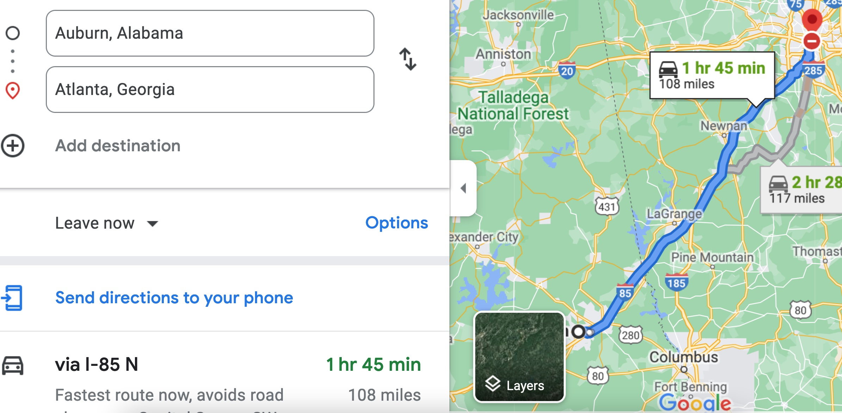

Therefore, the time t = 108 miles/60mph * 60 minutes/hour= 108 minutes. Since John left at 8am, he will then reach Atlanta at 8am + 108 minutes = 8 am + 60 minutes + 48 minutes = 9:48".

**Student 3** will get 25 + 15 + 60 = 100 points

Do you see the **direct** **link** going from the data provided in the question to the final answer, using general knowledge/formula and documents?.... Can you now solve the following problem and get 100 points?

"(100 points) Alice travels from Auburn to Atlanta in her car at a speed of 60 mph. Leaving at 8am, at what time will Alice reach Atlanta assuming that she had a flat tire that delayed her 30 minutes".